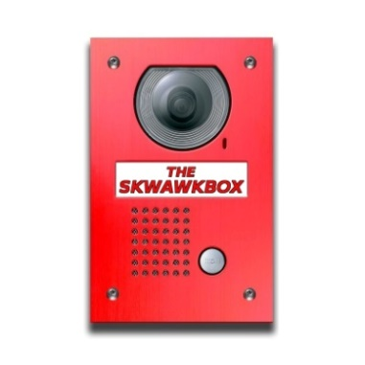
COMPLAINT LOG OF The SKWAWKBOX

- Unique Reference Number

- Date of Referral

- Method of Referral
- E-mail
- Letter
- Telephone
- Other

- Name of Complainant

- Organisation (if applicable)

- Address and postcode

- Type of complaint
- Affected party
- Representative group (public interest)
- Third party (accuracy)

- Reason for complaint
- Content of Published article
- Conduct or behaviour of employee/contributor
- Other

- Name of Publication

- Date of Publication

- Code standard(s) alleged to have been breached

- Date acknowledgement letter sent

- Date additional information requested

- Date progress letter sent

- Date final decision letter sent

- Outcome of complaint
- Upheld
- Part Upheld
- Rejected
- Withdrawn
- Other

- Where complaint upheld, Code standards that were found to have been breached

- Where complaint upheld, resolution that was reached
- Unpublished apology
- Published apology / correction
- Removal of article
- Other

- Final outcome
- Resolved without IMPRESS involvement
- Complaint upheld by IMPRESS
- Complaint part upheld by IMPRESS
- Complaint rejected by IMPRESS
- Other

- Description of action taken (if any) to improve Code compliance as a result of the complaint

