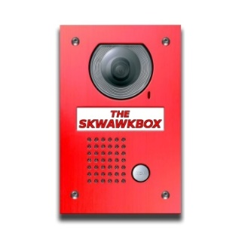

COMPLAINTS PROCEDURE OF THE SKWAWKBOX

Stage One: Making a Complaint
- Information on how to make a complaint is clearly publicised at https://skwawkbox.org/about/

- Complaints may be sent in writing to The SKWAWKBOX by e-mail at complaints@skwawkbox.com or telephone on or other reasonable means where this is more convenient and practical for the complainant.

- Complainants should provide the following information before their complaint will be considered:

  - The complainant's name, address, e-mail address and telephone number

  - If the complaint is about a news article it must include:
    - the name and date of the publication and page reference of the specific article being complained about plus the URL.
    - URL/Link to any visual or audio element of the complaint.
    - a written account of what is being complained about with clear reference made to (i) any specific words or phrases in the article that are relevant to the complaint; and (ii) any clauses of the Standards Code adopted by IMPRESS (“Code”) that the complainant believes to have been breached
    - The desired outcome or remedy sought by the complainant

- If the complaint is about the conduct or behaviour of an employee or contributor to The SKWAWKBOX it must include:
    - the name(s) of the individual(s) being complained about (if known) or any other information which may identify the individual (s)
    - a written account of what is being complained about with clear reference made to (i) the nature of the behaviour or conduct being complained about including any relevant times, dates, correspondence or other evidence to support the complaint; and (ii) any clauses of the Code that the complainant believes to have been breached
    - The desired outcome or remedy sought by the complainant

- The SKWAWKBOX will make reasonable efforts to contact a complainant by telephone, e-mail or in writing to ensure that sufficient information is provided to respond to the complaint.

Stage Two – Recording, Investigating and Resolving the Complaint
- The complaint information should be passed to the person responsible for legal standards and compliance (“The Complaints Editor”) at The SKWAWKBOX. They will record it in the complaints log and will acknowledge receipt of the complaint by e-mail or in writing within 7 calendar days of receipt of the complaint.

- The acknowledgement of receipt of a complaint should say who is dealing with the complaint and when the person complaining can expect a reply. Any conflicts of interest should also be declared at this point. A copy of this complaints procedure should be attached.

- The Complaints Editor is responsible for ensuring that the circumstances of the complaint are investigated fairly and that any conflicts of interest are managed. This may require the complainant to provide additional information, documents or other evidence to support their complaint.

- Complainants should receive a final decision letter within 21 calendar days from the date of the receipt of the complaint.

- The final decision letter must inform complainants that they have the right to refer their complaint to IMPRESS, stating the applicable time limits, set out in clause 4.4 of the IMPRESS Regulatory Scheme, and how to contact IMPRESS.

- Whether the complaint is justified or not, the reply to the complainant should describe the action taken to investigate the complaint, the conclusions from the investigation, and any action taken as a result of the complaint.
Stage Three – Escalating the Complaint to IMPRESS
- If the complainant feels that the problem has not been satisfactorily resolved by The SKWAWKBOX at Stage Two or if the complainant feels that the complaint is so urgent that they cannot wait for The SKWAWKBOX to respond, they can request that the complaint is reviewed by IMPRESS in accordance with its Regulatory Scheme, by contacting IMPRESS using the following details.
